Celebration of Worship

Gathering as God’s people to be inspired
to live as a community of Christ

+ Those who are able are invited to stand.
UMH - United Methodist Hymnal FWS – The Faith We Sing
You are invited to respond with the Bold responses.
Moments of Centering
I am constantly conscious of your thoughts. Sometimes your mind creates so many plans that they get tangled up in each other. The longer you indulge in obsessive planning, the farther you roam from awareness of My Presence. Although you may think you are planning your way, I am actually the One who directs your steps. However, you can choose the hard way (ignoring Me) or the right way (seeking My will). Be thankful for the mental confusion that occurs when you’re overly focused on your myriad plans. It can help to simply stop and laugh at yourself at such times. The most important response, though, is to turn back to Me quickly—saving precious time and energy.
As you entrust your concerns to Me, I receive them into My care and keeping. This lightens your load and helps you gain traction so you can move forward in dependence on Me. I don’t guarantee you a trouble-free journey, but I do promise to make your life meaningful. I will instruct you and teach you in the way you should go; I will counsel you and watch over you. Treasure My teaching in your heart, for it is not your plans but My counsel that will stand. –Jesus Lives, p. 84.

Good Morning! Welcome to Worship!

The Church Gathers to Worship

PRE-SERVICE MUSIC Renee Warner

WELCOME AND ANNOUNCEMENTS

PRELUDE Dan Martin

+CHORAL CALL TO WORSHIP UMH 94
Praise God, from whom all blessings flow; praise God, all creatures here below: Alleluia! Alleluia! Praise God, the source of all our gifts! Praise Jesus Christ, whose power uplifts! Praise the Spirit, Holy Spirit! Alleluia! Alleluia! Alleluia!

+CALL TO WORSHIP Responsively
No matter how far we wander from you, O God,
your steadfast love finds us.
No matter how unjust the world seems to us, O God,
your steadfast righteousness sustains us.
No matter how vulnerable our lives seem to us,
O God,
your steadfast presence gives us hope.
No matter how unloved and uncared for we feel,
O God,
you hear our cries and answer our prayers.
We lift up our voices in praise.
God's steadfast love never fails.

+INVOCATION Leader
Gracious and loving God, source of all wholeness, forgiveness, and mercy, may your Spirit heal those who are torn, mend those who are broken, and protect those who are fragile. Enable us, O God, through the gift of your steadfast love, to remember who we are and whose we are. In your love, may we be true and faithful disciples of your Son, Jesus Christ our Lord, in whose name we pray. Amen.

+HYMN OF PRAISE UMH 451
Be Thou My Vision
- Be thou my vision, O Lord of my heart; naught be all else to me, save that thou art. Thou my best thought, by day or by night, waking or sleeping, thy presence my light.
- Be thou my wisdom, and thou my true word; I ever with thee and thou with me, Lord; thou and thou only, first in my heart, great God of heaven, my treasure thou art.
- Great God of heaven, my victory won, may I reach heaven’s joys, O bright heaven’s Sun! Heart of my own heart, whatever befall, still be my vision, O Ruler of all.

The Church in Moments of Confession

THE PSALTER Psalm 36:5-10

PRAYER OF CONFESSION Responsively
Lord, how we must try your patience! We often doubt when we should place our faith in your abiding presence. We think that we have to have all the answers, and judge others who fail to live up to our expectations. We think that we are the one thing that matters most in life. So, we place ourselves at the center of our own universe.
Forgive us when we show how shallow our faith is. Help us to really understand the miraculous ways in which you have already worked in our lives and will continue to work as we journey in faith. Bring to us the Light of Joy, and let it flood through our whole beings, that we may be transformed into people of joyful service and faith. In Jesus' Name, we pray.

PERSONAL PRAYER OF CONFESSION

ASSURANCE OF FORGIVENESS Leader
God's love is continually poured out for us. Drink from the cup of forgiveness and compassion, dear ones. In Jesus' Name, we are forgiven!
Amen.

RESPONSE My Tribute UMH 99
To God be the glory, to God be the glory, to God be the glory for the things he has done. With his blood he has saved me; with his power he has raised me; to God be the glory for the things he has done.

The Church Prays and Listens

WIGGLETIME

CALL TO PRAYER FWS 2202
Come Away with Me, v. 5
Come away with me to a quiet place, to God's loving arms waiting to embrace all those who come in hope of grace. Come away with me. Come away.

PRAYERS OF INTERCESSION Pastor
A time of silence follows each petition.
God of steadfast love, you raise us up when we fall and place our feet on steady ground. Strengthened by your faithfulness, we offer our prayers in thanksgiving for the grace that is ours in Jesus Christ.

We pray for the mission of your church, that we may proclaim the Good News and the joy of your salvation as we put our trust in you.

We pray for the world, that your saving grace may reach to the ends of the earth as we serve the common good.

We pray for all who suffer, that we may heed their cry as we share in your steadfast mercy.

We remember before you those who are of poor health, those who are awaiting test results, those who are undergoing treatment, and we pray for those who grieve that they may know your healing mercies and peace.

Through Christ, in Jesus’ name, in the unity of the Holy Spirit, all glory and honor are yours, almighty Father, forever and ever.

THE LORD’S PRAYER Unison
Our Father, who art in heaven, hallowed be thy name. Thy kingdom come, thy will be done on earth as it is in heaven. Give us this day our daily bread. And forgive us our trespasses, as we forgive those who trespass against us. And lead us not into temptation, but deliver us from evil. For thine is the kingdom, and the power, and the glory, forever. Amen.

ANTHEM Chancel Singers
Down to the River to Pray
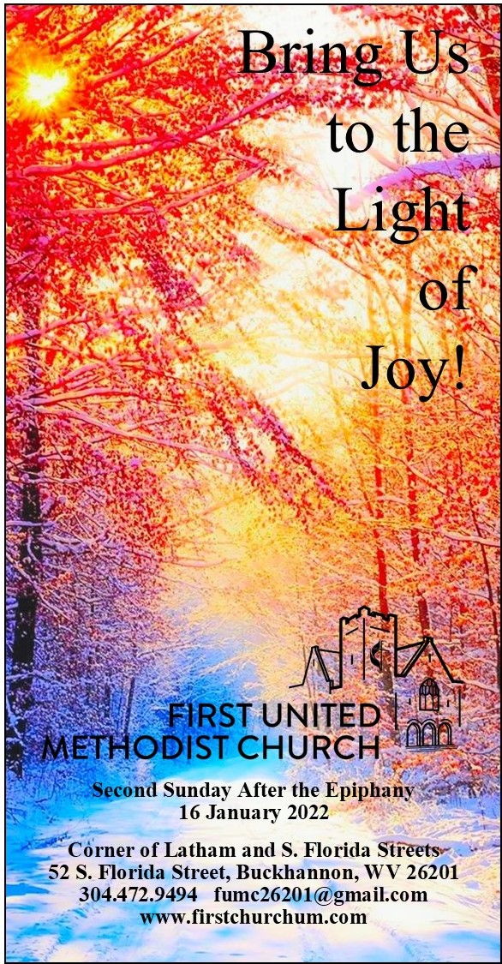
THE WORD

SERMON Rev. M. Steven Meadows

The Church Scatters as the Body of Christ

+HYMN OF DEDICATION UMH 140
Great Is Thy Faithfulness
- Great is thy faithfulness, O God my Father; there is no shadow of turning with thee; thou changest not, thy compassions, they fail not; as thou hast been, thou forever wilt be. Great is thy faithfulness! Great is thy faithfulness! Morning by morning new mercies I see; all I have needed thy hand hath provided; great is thy faithfulness, Lord, unto me.
- Summer and winter and springtime and harvest, sun, moon, and stars in their courses above join with all nature in manifold witness to thy great faithfulness, mercy, and love. Great is thy faithfulness! Great is thy faithfulness! Morning by morning new mercies I see; all I have needed thy hand hath provided; great is thy faithfulness, Lord, unto me.
- Pardon for sin and a peace that endureth, thine own dear presence to cheer and to guide; strength for today and bright hope for tomorrow, blessings all mine, with ten thousand beside! Great is thy faithfulness! Great is thy faithfulness! Morning by morning new mercies I see; all I have needed thy hand hath provided; great is thy faithfulness, Lord, unto me.

+BENEDICTION Pastor

+POSTLUDE

…and the worship continues.

